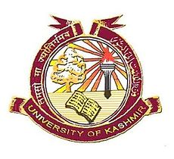
Centre of Central Asian Studies
University of Kashmir, Srinagar

Notice
The applicants who have been found eligible for admission to Ph.D./Integrated Ph.D./M.Phil in the disciplines of History, Islamic Studies, Political Science, Sociology and Library & Information Science are directed to attend Centre of Central Asian Studies, University of Kashmir on September 29, 2018 (Saturday) for verification of documents, interaction and counseling to be held at 11 am. Such applicants, who fail to attend, will not be considered for admission to aforementioned programmes.

Prof. G. N. Khaki
(Director)

Copy to:
1. Dean, School of Social Sciences
2. Dr. Muslim Jan for publicity in local dailies
3. All faculty members
4. Website
5. Notice Board
6. File

